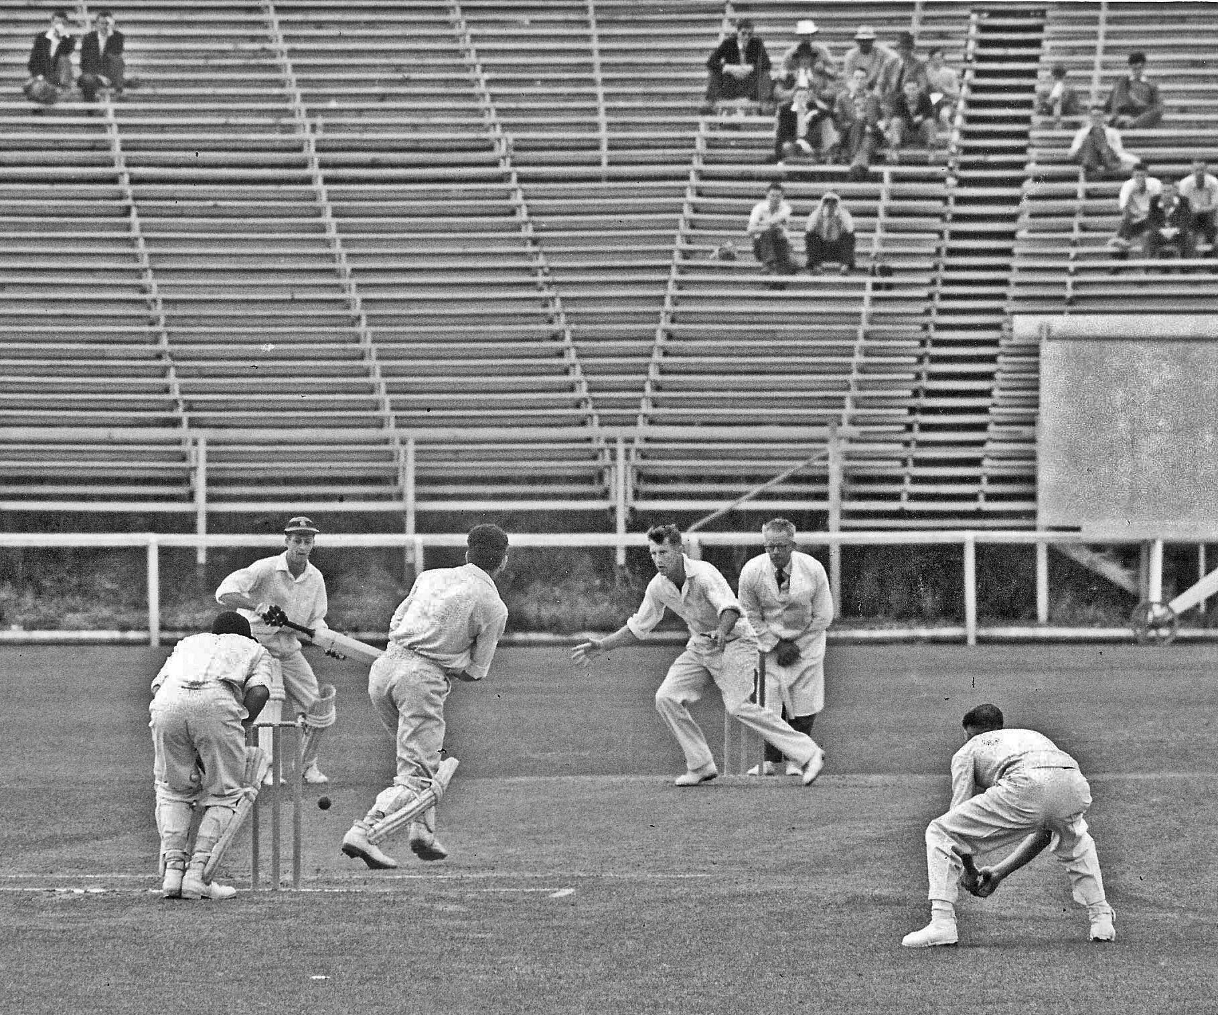

**SC Guillen on drives GD Alabaster, BA Bolton non striker.**

**Canterbury v Otago Lancaster Park 26 December 1959**

**Otago 96 and 278. Canterbury 284 and 91/4. Canterbury won by six wickets**